**Bryan Peens**

**Database Development 221**

**Project**

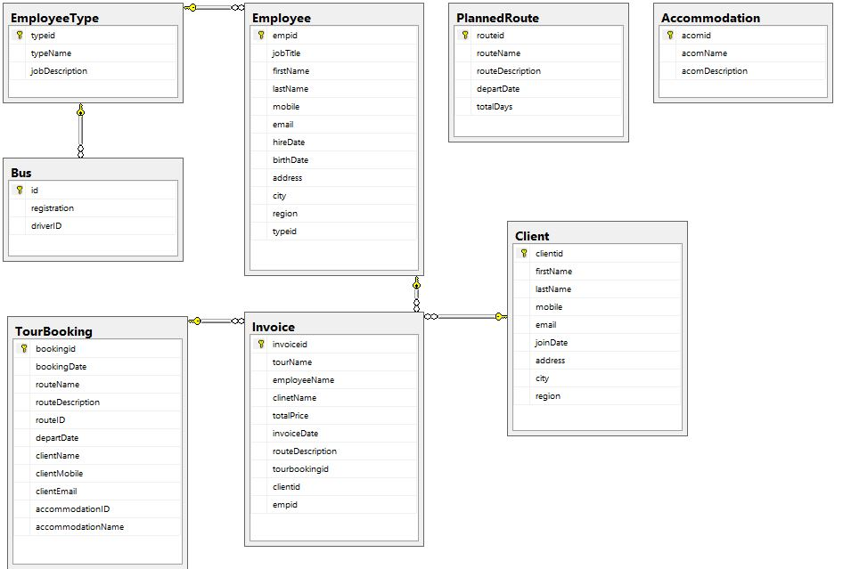

**LIST OF ALL TABLES:**

1. EmployeeType
2. Employee
3. Bus
4. TourBooking
5. Invoice
6. PlannedRoute
7. Accommodation
8. Client

**LIST OF ALL VIEWS:**

* V_Accommodation

Collects and returns record of accommodation related data, such as id and names

* V_CreateTours

Collects and returns tour related data that is used in a stored procedure

* ClientInvoice_VIEW

Retrieves invoice data related to a client

* Employee_VIEW

Will Retrieve data related to employees while used in a stored procedure

* V_acomName

Will Retrieve accommodation name

* V_getClientDetails

Will Collect data from the client table in order to view specific clients

**LIST OF ALL PROCEDURES:**

* [dbo].[CreateInvoice_SP]
* [dbo].[CreateTourBooking_SP]
* [dbo].[GetEmployee_SP]
* [dbo].[Insert_employee_SP]
* [dbo].[InsertAccom_SP]
* [dbo].[InsertBus_SP]
* [dbo].[InsertClient_SP]
* [dbo].[InsertEmployeeType_SP]
* [dbo].[InsertPlannedRoute_SP]
* [dbo].[UpdateAccommodation_SP]
* [dbo].[UpdateBus_SP]
* [dbo].[UpdateClient_SP]
* [dbo].[UpdateEmployee_SP]
* [dbo].[UpdateEmployeeType_SP]
* [dbo].[UpdatePlannedRoute_SP]